8-BIT RISC PIPLINED PROCESSOR IMPLEMENTATION ON FPGA

by

MUHAMMAD SHAHID
CE131001

A Project Report submitted to the
DEPARTMENT OF ELECTRONIC ENGINEERING
in partial fulfillment of the requirements for the Course of
ADVANCED ASIC DESIGN AND FPGA

Faculty of Engineering
Mohammad Ali Jinnah University
June, 2013

DECLARATION

It is declared that this is an original piece of my own work, except where otherwise acknowledged in text and references. This work has not been submitted in any form for another degree or diploma at any university or other institution for tertiary education and shall not be submitted by me in future for obtaining any degree from this or any other University or Institution.

Muhammad Shahid

CE131001

June 2013

BSTRACT

This report gives a brief description of the design and Verilog implementation of a RISC CPU.

KEYWORDS

RISC, CPU, Pipeline,, Logic, Verilog, Digital Circuit
Single Cycle Processor 5
Instruction Set Architecture 5
R Type of Format 5
I Type of Format 5
J Type of Format 5
RISC Instruction Sub Set 6
Register Transfer Level(RTL) 7
Implementation in HDL 8
Computational Elements 8
Storage Elements 8
Clocking Methodology 8
8 Bit Single-Cycle RISC Processor Data-path and Control Unit 9
Implementation Procedure 10
Single-cycle Timing simulation 10
FPGA Used Resources view 12
Conclusion 12
Refrences 12

Single Cycle Processor
Instruction Set Architecture: In this project, I have design a simple 8-bit RISC processor with 4, 8-bit general-purpose registers: R1 through R14. R0 is hardwired to zero and cannot be written, so I have left with 14 registers. There is also one special-purpose 4-bit register, which is the program counter (PC). All instructions are 4 bits. There are three instruction formats, R-type, I-type, and J-types as shown below:
R-type format: 4-bit opcode (Op), and 4-bit register numbers (Rd, Rs, and Rt)
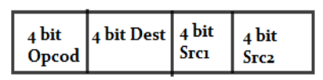
I-type format: 4-bit opcode (Op), 4-bit immediate constant and 4-bit register number (Rs and Rt)
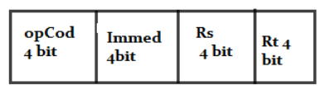
J-type format : 4-bit opcode (Op) Sr1 4 bit Sr2 4 bit and 4-bit immediate constant
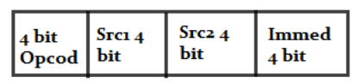
For R-type instructions, Src1 and Src2 specify the two source register numbers, and Dst specifies the destination register number. We can reserve several opcodes for R-type instructions. For I-type instructions, Rs specifies a source register number, and Rt can be a second source or a destination register number. The immediate constantis only 4 bits because of the fixed-size nature of the instruction. The size of the immediate constant is suitable for our uses. The 4-bit immediate constant should be unsigned.

RISC Instruction Sub Set
Instruction | Meaning | Format
add rd, rs, rt | addition | op4 = 0x1 | rs4 | rt4 | rd4
sub rd, rs, rt | subtraction | op4 = 0x2 | rs4 | rt4 | rd4
and rd, rs, rt | bitwise and | op4 = 0x3 | rs4 | rt4 | rd4
or rd, rs, rt | bitwise or | op4 = 0x4 | rs4 | rt4 | rd4
Slt rd, rs, rt | Shift left | op4 = 0x5 | rs4 | rt4 | rd4
Srt rd, rs, rt | Shift right | op4 = 0x6 | rs4 | rt4 | rd4
addi rt, rs, im4 | add immediate | op4= 0x7 | rs4 | rt4 | im4
subi rt, rs, im4 | Subtraction immediate | op4=0x08 | rs4 | rt4 | im4
ldi rt, rs, im4 | load immediate | 0x0b | rs4 | rt4 | im4
swi rt, rs, im4 | store immediate | 0xc | rs4 | rt4 | im4
NOP | No operations | 0x0 | 0 | 0 | 0
lw rt, im4(rs) | load word | 0x9 | rs4 | rt4 | im4
sw rt, im4(rs) | store word | 0xa | rs4 | rt4 | im4
jeq rs, rt, im4 | branch if equal | 0xd | rs4 | rt4 | im4

Register Transfer Level(RTL)
RTL is a description of data flow between registers. RTL gives a meaning to the instructions. All instructions are fetched from memory at address PC
Instruction RTL Description
ADD Reg(Rd) ← Reg(Rs) + Reg(Rt); PC ← PC + 4
SUB Reg(Rd) ← Reg(Rs) – Reg(Rt); PC ← PC + 4
OR Reg(Rd) ← Reg(Rs) | Reg(Rt); PC ← PC + 4
LW Reg(Rt) ← MEM[Reg(Rs) + sign_ext(Im16)]; PC ← PC + 4
SW MEM[Reg(Rs) + sign_ext(Im16)] ← Reg(Rt); PC ← PC + 4
BEQ if (Reg(Rs) == Reg(Rt))
R-type Fetch instruction: Instruction ← MEM[PC]
Fetch operands: data1 ← Reg(Rs), data2 ← Reg(Rt)
Execute operation: ALU_result ← func(data1, data2)
Write ALU result: Reg(Rd) ← ALU_result
Next PC address: PC ← PC + 4
I-type Fetch instruction: Instruction ← MEM[PC]
Fetch operands: data1 ← Reg(Rs), data2 ← Extend(imm16)
Execute operation: ALU_result ← op(data1, data2)
Write ALU result: Reg(Rt) ← ALU_result
Next PC address: PC ← PC + 4
BEQ Fetch instruction: Instruction ← MEM[PC]
Fetch operands: data1 ← Reg(Rs), data2 ← Reg(Rt)
Equality: zero ← subtract(data1, data2)
Branch: if (zero) PC ← PC + 4 + 4×sign_ext(imm16)
else PC ← PC + 4
LW Fetch instruction: Instruction ← MEM[PC]
Fetch base register: base ← Reg(Rs)
Calculate address: address ← base + sign_extend(imm16)
Read memory: data ← MEM[address]
Write register Rt: Reg(Rt) ← data
Next PC address: PC ← PC + 4
SW Fetch instruction: Instruction ← MEM[PC]
Fetch registers: base ← Reg(Rs), data ← Reg(Rt)
Calculate address: address ← base + sign_extend(imm16)
Write memory: MEM[address] ← data
Next PC address: PC ← PC + 4
Jump Fetch instruction: Instruction ← MEM[PC]
Target PC address: target ← PC[31:28] , Imm26 , ‘00’
Jump: PC ← targe
Implementation in HDL
Combinational Elements:
ALU, Adder Immediate extender, Multiplexers

Storage Elements: (show block diagram of you storage elements)

Clocking Methodologies: Clocks are needed in a sequential logic to decide when a state element (register) should be updated.To ensure correctness, a clocking methodology defines when data can be written and read. We assume edge-triggered clocking. All state changes occur on the same clock edge. Data must be valid and stable before arrival of clock edge. Edge-triggered clocking allows a register to be read and written during same clock cycle.

8 Bit Single-Cycle RISC Processor Data-path and Control Unit
Data-path including combinational and memory(sequential) elements is controlled by control unit. Operation code of an instruction is input of control unit. A complete circuit diagram of 8 bit single-cycle processor is shown below.(replace the given below diagram with nice one)
PCSrc
Ext
Data
Memory
Address
Data_in
Data_out
8
A
L
U
ALU result
8
4

Registers
RA
RB
BusA
BusB
RW
BusW
8
Address
Instruction
Instruction
Memory
PC
00
+1
8
Rs
4
Rd
Imm4
Rt
m
u
x
0
1
4
m
u
x
0
1
m
u
x
0
1
m
u
x
0
1
8
8
Jump or Branch Target Address
8
Imm4
Next
PC
zero
ALU
Ctrl
ALUCtrl
ALUOp
func
RegDst
ALUSrc
RegWrite
J, Beq, Bne
MemtoReg
MemRead
MemWrite
ExtOp
Main
Control
Op

Implementation Procedure:
All components implemented and tested individually, So it is make sure there should problem in individual part. Then they are combined gradually to complete the functionality of processor. Complete RTL Schematic and Technology schematic of Single-cycle RISC Processor is shown below.
Single-cycle Timing simulation
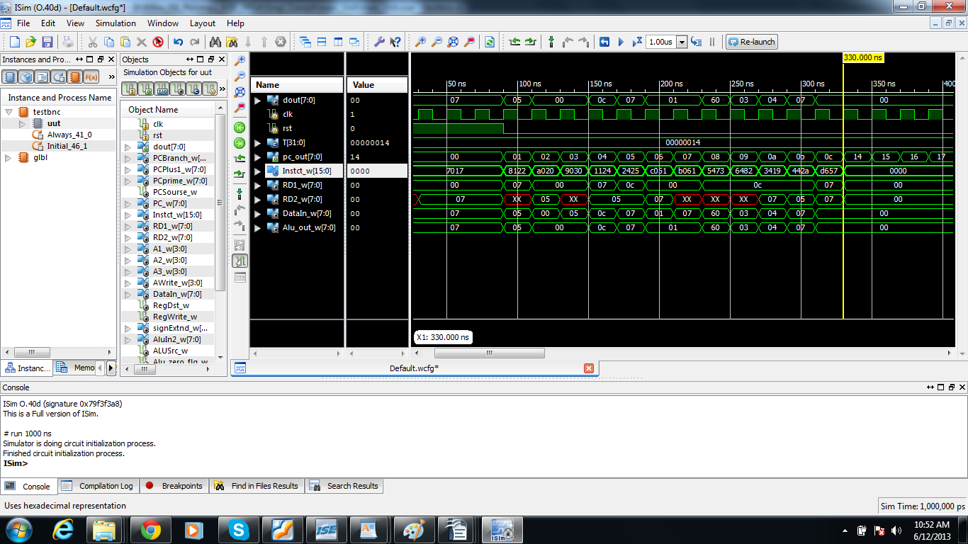
Figure timing diagram of single-cycle processor.
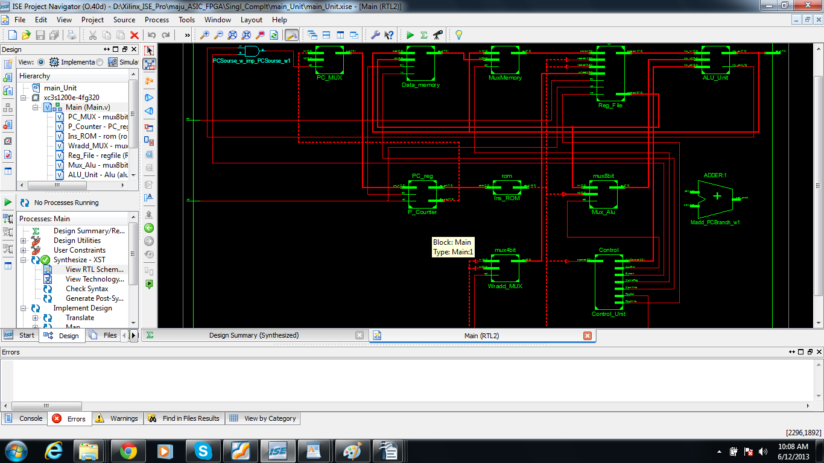
Figure RTL Schematic of Single-cycle processor.

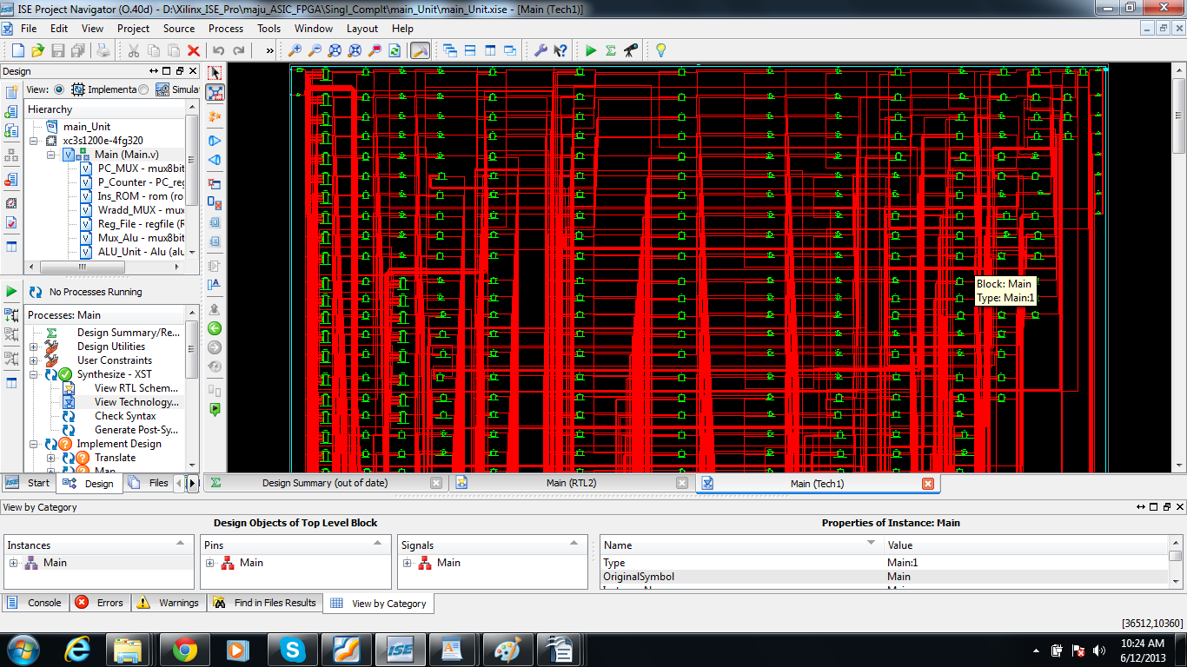
Figure Technology Schematic of Single-cycle processor.
This single-cycle processor is using very small resources of FPGA. Device utilization summary is given below.

FPGA Used Resources view
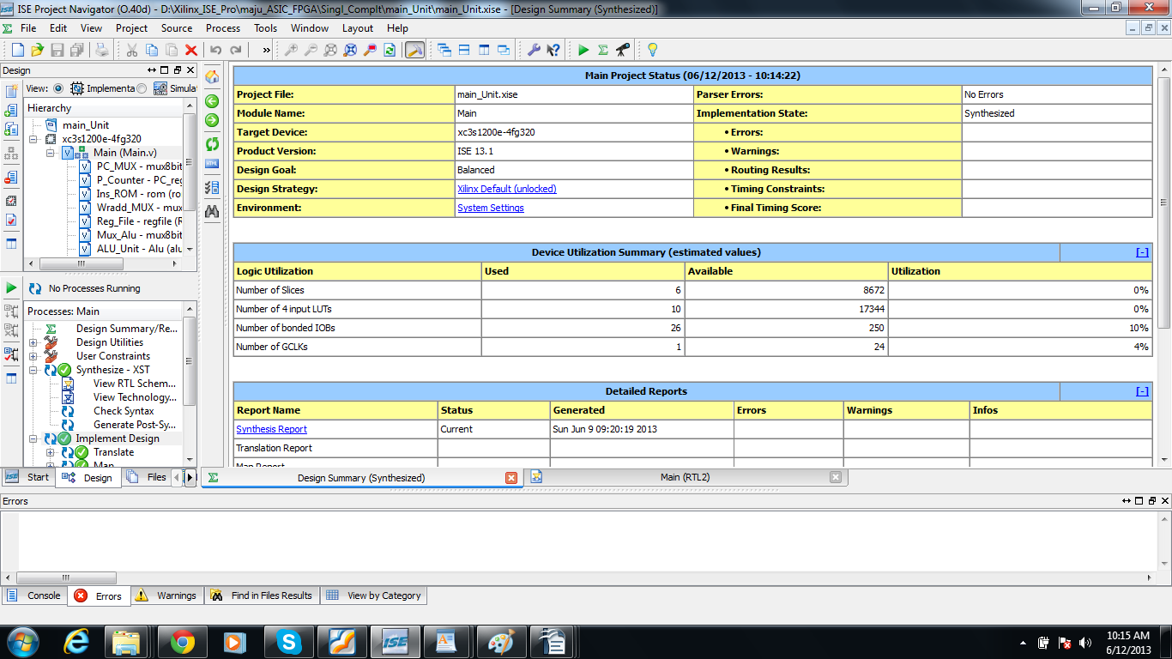
using plane ahead tool of Xilinx ISE the used resources for processor is shown below.
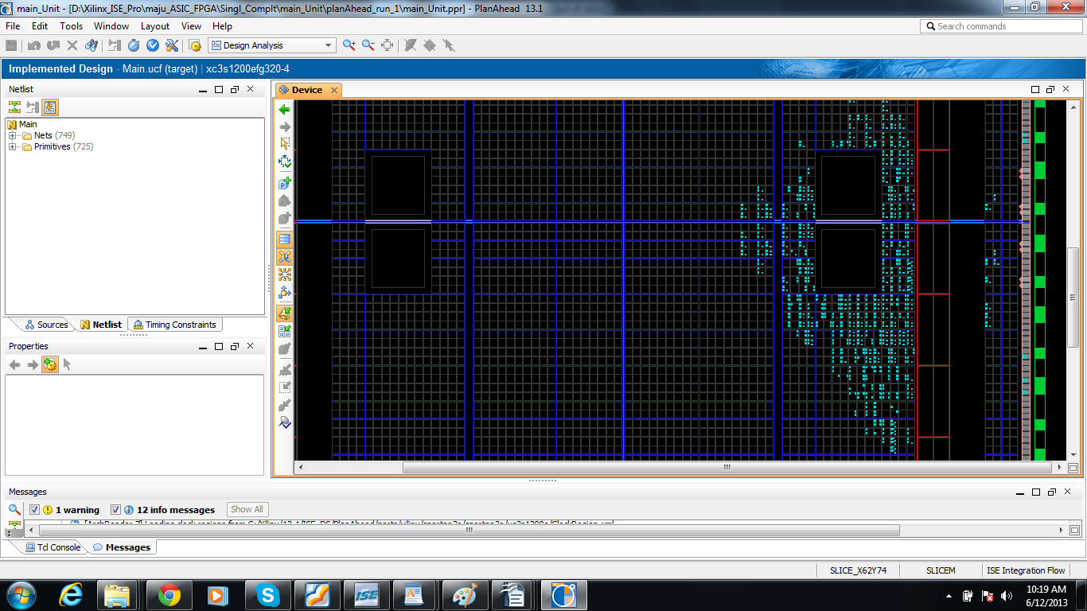

Conclusions
In this practice, I’ve successfully accomplished buiding a RISC CPU. The hierarchy of storage is fully demonstrated in this practice.
From the practice, I’ve get more familiar with computer architecture and organization. Through this practice, I have got a very deep impression about Processor Architecture. As a byproduct, I learned how to use verilog to build digital circuits and how to debug it by writing benchmarks and watching waveforms. And above all, it endows me with patience and carefulness to do things in an orderly way. This practice is really a valuable lesson for my Master level study.

References
[1] http://opencourseware.kfupm.edu.sa/colleges/ccse/coe/coe308/files/2-Lecture_Notes_08-SingleCycleProcessor.pdf
[2] http://opencourseware.kfupm.edu.sa/colleges/ccse/coe/coe308/files/2-Lecture_Notes_10-PipelinedProcessor.pdf
[3] David A Patterson, John L Hennessy. Computer Architecture: A Quantitative Approach. Third Edition.
[4] Advanced Digital Design with the verilog hdl by michael d. ciletti

